**Halcon and Visual Studio Configuration Cheat Sheet**

**1)** Download and install Visual Studio **2015** Community Edition (yes, it’s free, choosing all default options will work fine)

**2a)** Download the latest version of Halcon

**2b)** Run the installer (choosing all the defaults will work fine)

**3)** From my [MicrocontrollersAndMore GitHub](https://github.com/MicrocontrollersAndMore/OpenCV_3_Windows_10_Installation_Tutorial) page decide which example you are going to use, if you are going through this for the first time I suggest *CountDiceDots.vb*

**4a)** Start Visual Studio

**4b)** Make a new project

**4c)** Choose Visual Basic or Visual C#, Windows Forms Application, name the project as you prefer, ex "CountDiceDots", and choose your preferred project location. I recommend unchecking "Create directory for solution" and "Add to source control", then choose OK.

**4d)** Save the project (continue saving throughout as needed)

**5)** Rename your main form if desired, for example "frmMain". It's much better to do this now than later. When asked "Would like to perform a rename in this project of all references?" answer "Yes".

**6a)** In the toolbar, choose the drop down box for "Solution Platforms", then choose "Configuration Manager . . .", or alternatively in the menus choose Build -> Configuration Manager

**6b)** Under "Platform", next to "Any CPU", choose the drop down box, then choose "<New . . .>"

**6c)** Under "New Platform", choose "x64", under "Copy settings from", choose "Any CPU", verify "Create new solution platforms" is checked, then choose "OK", then in Configuration Manager choose Close

**6d)** On the toolbar, verify that "Solution Platforms" is now set to "x64"

**7a)** Go to: "Project -> Add Reference -> Browse -> Browse..."

**7b)** Navigate to the directory with the Halcon DLL, ex "C:\Program Files\MVTec\HALCON-12.0\bin\dotnet35"

**7c)** Double click “halcondotnet.dll”

**8a)** Go to: "Project -> Add Existing Item"

**8b)** Navigate to directory with the Halcon DLL, ex "C:\Program Files\MVTec\HALCON-12.0\bin\dotnet35"

**8c)** Change viewable files to "All Files (*.*)" (drop down box in the lower right corner of the screen)

**8d)** Double click “halcondotnet.dll”

**9a)** Within Visual Studio, in Solution Explorer, highlight all the DLLs that was just added

**9b)** In the Properties window, set "Copy to Output Directory" to "Copy always"

**10)** The following will add the special Emgu controls to the Toolbox (you only have to do this once):

**10a)** Choose Design View (where you edit the form) if you are not in Design View already

**10b)** Bring up the Toolbox, the usual controls will be there (Button, Text Box, etc.)

**10c)** Expand "General"

**10d)** Right click in an empty area of General, choose "Choose Items . . ."

**10e)** ImageBox will not be listed yet

**10f)** Choose "Browse..."

**10g)** Navigate to the Halcon DLL, ex "C:\Program Files\MVTec\HALCON-12.0\bin\dotnet35"

**10h)** Double click on "halcondotnet.dll" (or single click and choose OK)

**10i)** HWindowControl should be listed now, check it if it is not already checked, then choose OK

**10j)** Move "General" to the top of the toolbox so the HWindowControl is easily accessible

**10k)** If these steps do not work, locate one of the Visual Studio examples that ships with Halcon, open it in a separate instance of Visual Studio, and copy/paste the HWindowControl into your current project

**11a)** Add the following controls to your form:

frmMain (should already be there from the previous steps)

tableLayoutPanel (2 rows x 3 columns)

btnGetImageFromFile (in row 1, column 1)

btnGetImageFromCamera (in row 1, column 2)

lblInfo (in row 1, column 3)

hWindowControl (in row2, column 1, then set ColumnSpan to 3)

openFileDialog (goes in the gray area at the bottom of the Visual Studio design window)

**11b)** When done, your form should look like this:

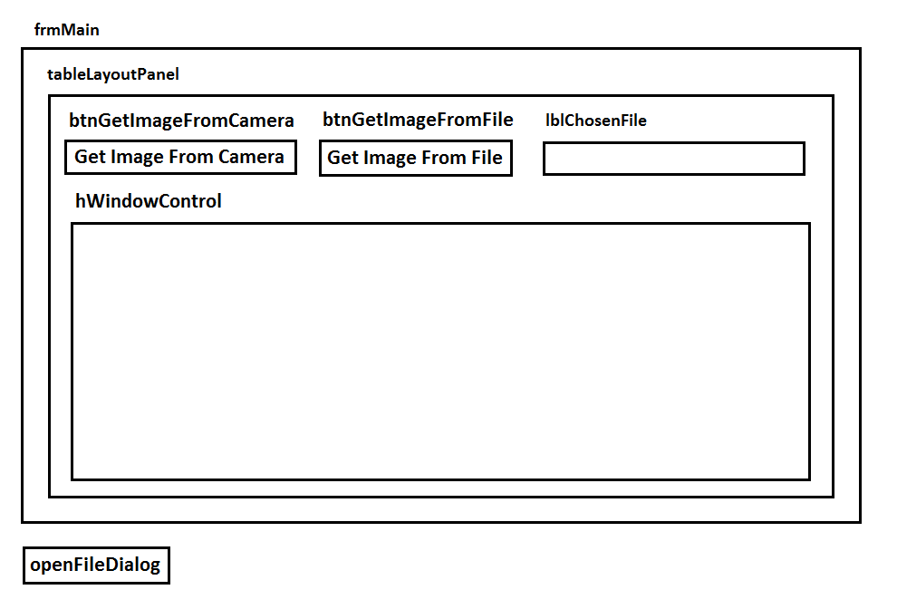

**12a)** Check the code for your chosen example to see which events are present, for example a Button Click or a Form Load

**12b)** If your chosen example uses a button, for example btnOpenFile, verify the button is correctly named, then double click on the button in the design view. This will write the first and last lines of btnOpenFile_Click() for you.

**12c)** If your chosen example uses a frmMain_Load event, in design view double click on an open area of the form, or the title bar of the form if there is no open area, this will write the first and last lines of frmMain_Load for you. Alternatively, in design view choose the form, then go to ***Properties -> Events (lightning bolt icon) -> double click on "Load"***.

**12d)** Perform similar steps to **14b)** and **14c)** for any other components that respond to events

**13)** Copy/paste the *remaining code only* (do **not** copy/paste over the entire file and do **not** change the code that Visual Studio wrote for you) from your chosen example, then run (with or without debugging)